Predicting an Ideal Location for a Bubble Tea Shop in Santa Clara
Nicole Chan
- Introduction
Originally, I wanted to investigate the boba shops in San Diego. I was not able to because of some technical difficulties I had found while finding the data for the individual regions in San Diego County. The divisions were difficult to isolate into a file that was agreeable to this analysis. I also learned that Foursquare only allows one to look up certain aspects of venues. It does not provide all of the information I wanted to use to accurately rate a boba shop. I switched to investigating the shops in Santa Clara County and where the most profitable shop would be with respect to the population density and the existing boba stores.
Background:
As of 2019, the population estimates is 1.9 million people. I used the census data from 2010 where the population was roughly 1.8 million people. The population of the South Bay Area is 7.8 million. There is a higher concentration of ‘foodies’ in the Bay Area and they are willing to travel to new places to try food. The local population and the surrounding area will be huge contributors to a store’s success.
Problem:
With a large number of boba places that already exist, it is hard to place a new boba shop at random.
Interest:
It is better to strategically place a shop with a high population density and farther from other existing stores.
- Data acquisition and cleaning
Data Source:
I first retrieved the census data from 2010. I then used it to make a map of Santa Clara County and determine the density per block. The densities were mapped in relation to person/sqkm.
Data Cleaning:
I began gathering all possible venues in Santa Clara County. From there, I was able to filer out only those that were Bubble Tea stores and organized by zipcode. While organizing by zipcode, I had to reformat zipcodes, correct the number of digits for entries, and delete duplicates. I used all the possible venues in comparison with bubble tea stores to determine foot traffic and other attractive stores in the area. With the bubble tea stores dataframe, I sorted by likes, ratings, and tips.
Feature Selection:
After, I organized by neighborhood in Santa Clara. I filtered out neighborhoods that were too small to have any businesses. The neighborhoods were then organized by ID and the bubble tea stores were organized by rating and merged. The data from all possible venues were used to determine the attractiveness factor and used to calculate the most common venues for the rated bubble tea stores.
- Exploratory Data Analysis
For all of the bubble tea stores, the linear regression was taken to calculate the relationship between population density and bubble tea shop popularity. 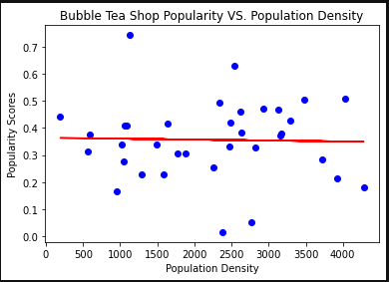
The R² score is -1564.93. the mean absolute error is 0.11 and the MSE is 0.02. a negative R2 score typically means the data is not reliable, but in this case I did not set a constant.
The goal of this project is to look at the ideal placement for a new boba shop near a high population density and not near to other existing boba shops. I gathered information to look at the high population densities and popular boba shops (red circles). 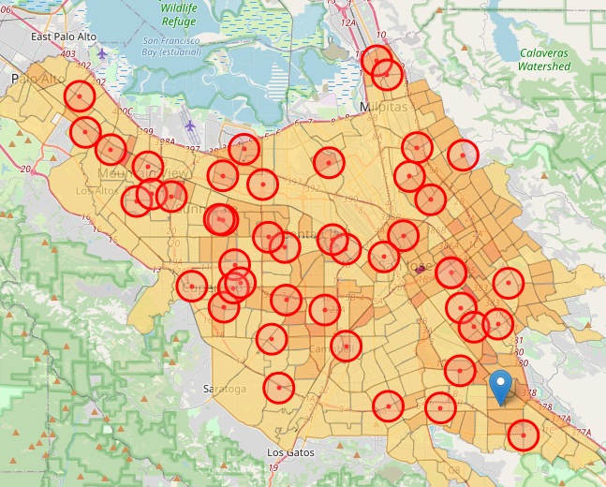
- Predictive models
Using the logistic regression, K-nearest neighbor, SVM and decision trees, the highest F1 scores and jaccard scores were achieved using the K-nearest neighbors. Using the K-nearest neighbor method, I was able to classify the ideal place to open a new boba shop. These green circles indicate ideal places to open a boba shop with higher population density and vicinity to other attractive stores.
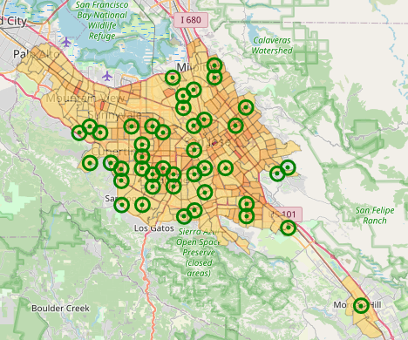
Using all the measurements, I have compiled the information into this map. Red circles indicate existing boba shops. Purple circles indicate potential areas to open a shop. Blue circles indicate areas that are qualified to have a boba shop that meet the criteria.
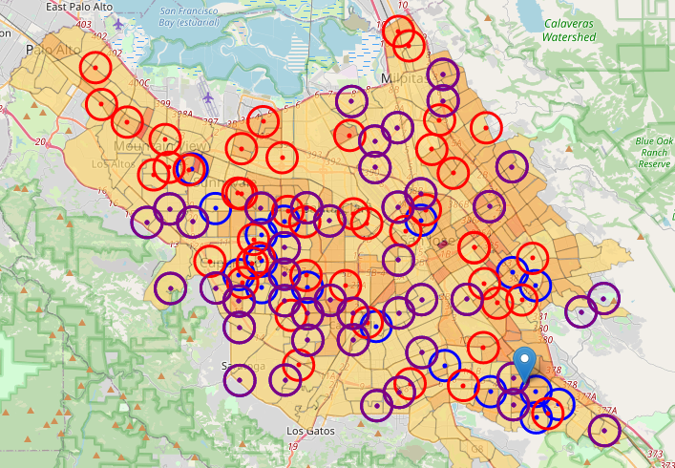
I chose to focus on the potential areas because the qualified areas were very near the already existing boba shops. These four places are marked below.
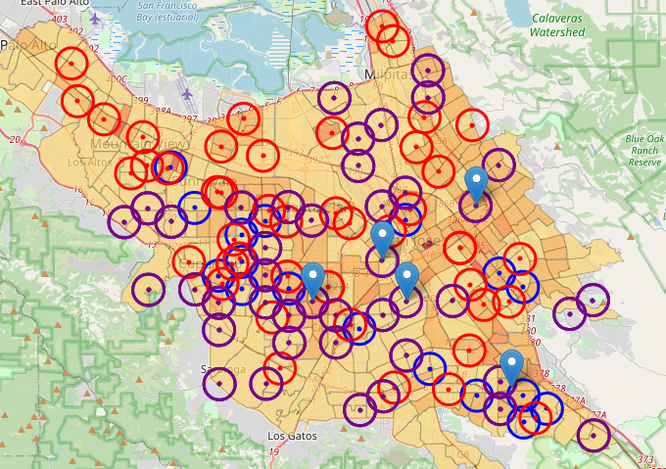
- Conclusions
Purpose of this project was to identify existing Bubble Tea Shops in Santa Clara County in narrowing down the search for optimal location for a new Bubble Tea Shop. We gathered and cleaned 2010 National Censes Data to identify density distribution of the area, Foursquare API to explore all currently active Bubble Tea Shops as well as to identify Venue Attributes of both Bubble Tea Shops and defined neighborhoods in 1 km radius circle, and demographical date from the County Heathy Department. We also performed and compared four different Classification Machines Learning algorithms and decided to use Logistic Regression as the prediction model of this project. We selected the top 100 most frequent venues around Bubble Tea Shops as target features. The final prediction was preformed to come up 37 qualified candidate locations. Four locations were suggested due to further conditions considered such as avoiding to overlap the 1 kilometer range with current existing Bubble Tea Shops and as closer to a high density area as possible.

Final decision on optimal Bubble Tea Shop location will be made by stakeholders based on specific characteristics of neighborhoods and locations, preference of stakeholders, taking into consideration additional factors like amiabilities of plazas or shopping malls, accessibilities (major roads or freeways), rental prices, social and economic dynamics of the neighborhood etc.

I had learned that Foursquare API does not have data that would help me in determining the availability of a parking lot, location close to freeways, or handicap accessibility. This will ahve to be considered in the future for this decision.

